## DELEGATES

Delegates are users who have been granted permissions to manage another user’s Direct inbox, including reading messages, replying/forwarding, and composing new messages. Each user is able to add and remove delegates at any time using the **Settings** tab on the *Messages* screen.

### Adding Delegates

To grant an HIE user the ability to read and write Direct messages on your behalf, enter the Direct address of that user in the **Direct Address** field of the *Delegates* section.

If the delegate user’s address is part of the current user’s Direct domain, it will automatically be added to the list of delegates. If the address is not part of the current user’s Direct domain, click the **Add** link. If the Direct address can be verified, it will be added; otherwise, an error message will appear.

Multiple users can be added as delegates. To remove any previously added Direct addresses, click the red **X** at the end of the delegate’s row.

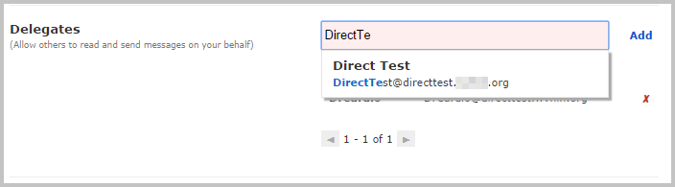

### Acting as a Delegate

If another user has added you as a delegate, you can access his or her Direct account by clicking on the direct address in the upper right of your Direct **Inbox** screen.

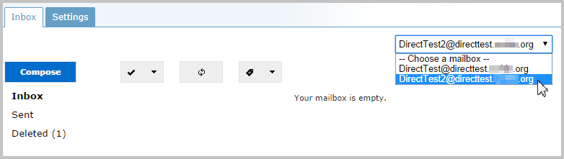

Select a Direct user address from the *Choose a Mailbox* dropdown to switch to that user’s Direct inbox.

As a delegate, you will be able to read, write, reply to, and forward Direct messages within the delegated inbox. Users should keep in mind their organization’s privacy and security policies before setting up any delegates.

Note: only the original inbox owner can assign and delete delegates to his or her inbox.

Messages sent by a delegate will include a notification that they were sent on behalf of another user.

